**Algorithm and Data Analysis**

This algorithm and data analysis is not included in the presentation of 30% of the system. However, this will explain what algorithms and analytics will be used in the entire system.

The C4.5 algorithm will be used in system development. This algorithm will be used to build a Decision Tree which is under the classification analytics. Rules in C4.5 algorithm can easily be understood with the use of natural language and can be expressed in the form of database language such as SQL (Structured Query Language) to query records in specific categories. In order to form a decision tree, the C4.5 algorithm process is used to identify attributes that will serve as the roots of the tree. The branches of the decision tree will serve as the question for the classification and leaves will be the classes or the groups.

In a scholarship application, there are several requirements such as grades, GWA, economic status, parent’s occupation, and number of siblings. The use of the C4.5 algorithm directly shows the pattern of data in the decision tree to decide if the scholars are potential to accept the application. The method that will be used in the application of C4.5 algorithm in FAMS: Financial Assistance Management System is designed below:

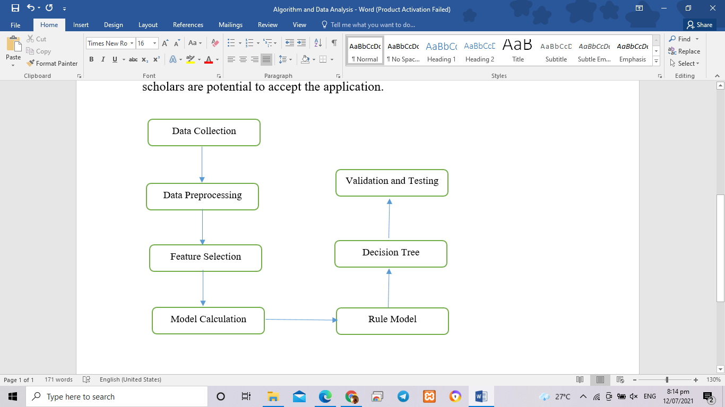

**Data Collection**

       Data Collection is the process of collecting data that will be used in the application of C4.5 algorithm.

**Data Preprocessing**

       This is the process of transforming and converting the data in appropriate form to process the calculation of the C4.5 algorithm.

**Feature Selection**

       This will be the selection of data to use in the C4.5 classification algorithm. This is to create and select a target data set where the discovery will be made.

**Model Calculation**

       This is the calculation of all attributes or variables, information gain, and identifying the highest information gain.

**Decision Tree**

       This will be the result of the process of calculation entropy and information gain. There will be several calculations until all tree attributes have a class and have done the calculation process.

**Rule Model**

       This description represents a decision tree.

**Validation and Testing**

       This process will help to know if all the functions work well or not. Confusion matrix will be used for the validation. This process will also help to determine the accuracy and precision of the classification results.